Superstore Data Analysis Project Documentation
A SQL, Python & Power BI Data Analytics Project
Name: Sudhishma Pallerla
Batch: BN010

INDEX
- PROJECT OVERVIEW
  - Tools & Technologies
  - What Can We Find in This Project
- OBJECTIVES
- DATA COLLECTION & SOURCE
- DATA CLEANING & TRANSFORMATION
  - a) Data Cleaning Steps
  - b) Cleaning Impact
  - c) Data Structure After Cleaning
  - d) Column Reference, Calculated Columns & Measures (DAX)
- DATA MODEL
  - Relationships
  - Important Model Rules
- DASHBOARD DEVELOPMENT
  - a) Purpose
  - b) Key KPIs
  - c) Visualizations Used
  - d) Slicers
- KEY INSIGHTS
- BUSINESS RECOMMENDATIONS
- CONCLUSION

1. PROJECT OVERVIEW
This portfolio project presents an end-to-end data analytics and business intelligence solution designed for an executive team to evaluate the historical operational performance of a multi-regional US Superstore retail chain.
The pipeline bridges programmatic data cleaning and exploratory data analysis (EDA), enterprise-grade database engine architectural design, and modern interactive dashboard reporting. It ingests raw, highly inconsistent, transaction-level records and processes them through an automated extract-transform-load (ETL) pipeline to surface macro-level KPI tracking, category health analytics, and sub-category growth anomalies.
Raw Data Inconsistent Ingestion (10,014 Rows)
│
▼
[ Python Pandas & NumPy Engine ]
├── Deduplication & Whitespace Stripping
├── Typo Imputation & Categorical Standardization
└── Null Value Vectorized Imputation
│
▼
Cleaned Dataset Ingested into Database (9,995 Rows)
│
▼
[ MySQL Production Database Server ]
├── Star Schema Extraction (dim_customer, dim_product)
├── Calculated Functions, Triggers, and Storage Procedures
└── Window Function Time-Series Materialization
│
▼
[ Power BI Business Intelligence Suite ]
├── Star Schema In-Memory Star Schema Modeling
├── Analytical DAX Performance Measures
└── Multi-View Enterprise Interactive Dashboards
Tools & Technologies
- Data Processing & Prototyping: Python 3.x with Pandas, NumPy, Seaborn, and Matplotlib libraries.
- Database Infrastructure & Data Warehouse Engineering: MySQL Server Core (superstore_db) using User-Defined Functions (UDFs), Stored Procedures, Advanced Window Functions, and Automation Triggers.
- Business Intelligence & Production-Grade Data Visualization: Power BI Desktop / Service leveraging custom-designed data modeling, complex Data Analysis Expressions (DAX) programmatic measures, and corporate-themed dashboard layouts.
What Can We Find in This Project
- A standalone data validation script handling raw data anomalies, text normalization, and vectorized null handling.
- A relational database schema configured to run ad-hoc business query reporting, time-series running cumulative tracking, and internal database audit-logging triggers.
- An interactive enterprise business intelligence suite consisting of an extensive data semantic layer model and multi-perspective insights across financial performance, geographic density, and product category diagnostics.

2. OBJECTIVES
- Data Reliability: Build a scalable data prep script to surface and clean structural noise, multi-case records, text whitespaces, and critical missing value parameters.
- Database Modernization: Transition flat transactional files into an optimized Star Schema design inside an ACID-compliant RDBMS to facilitate sub-second query performance and query isolation.
- Executive Intelligence Reporting: Construct a single source of truth matrix reporting layer tracking Total Sales, Total Profit, Profit Margin %, Total Quantity, and Order Volume across time-series, categorical hierarchies, and demographic segments.
- Leakage Diagnostics: Programmatically dissect the interaction between promotional product discounting and structural profit compression, explicitly identifying low-margin product lines.

3. DATA COLLECTION & SOURCE
The foundational raw input data utilized throughout this business intelligence implementation originates from a transactional retail database: Superstore_Inconsistent_Data.csv. The source file reflects line-item data recording individual transactions spanning global logistical delivery modes, detailed geographic location nodes across various states, granular customer segment breakdowns, and financial line-item variables representing raw sales pricing numbers, product quantities, applied discount coefficients, and localized calculated profit outcomes.

4. DATA CLEANING & TRANSFORMATION
a) Data Cleaning Steps
Executed programmatically via Python Pandas/NumPy prior to database ingestion, the data cleaning pipeline implemented the following steps:
- Deduplication: Identified and dropped exact duplicate row logs to prevent artificial inflation of sales volume metrics.
- Structural Text Normalization: Iterated over all text categorical features (Segment, Ship Mode, Category, Region, Country, Sub-Category, City, State), striping hidden white spaces, and casting inputs to uniform Title Case. String equivalents of Nan or None were explicitly resolved to true Pandas NA tokens.
- Typo Imputation: Standardized systemic structural naming errors across product classifications, mapping misaligned instances like Office Supply into the verified uniform master string Office Supplies.
- Temporal Parsing: Coerced Order Date and Ship Date properties into explicit ISO 8601 datetime format strings (YYYY-MM-DD), handling inconsistent date syntax gracefully using vector coercion models.
- Missing Value Treatment: Filled null numerical columns in the Discount array using the robust median of the sample set to protect summary distributions against skewed pricing effects. Imputed missing categorical geo-demographic records (Ship Mode, City, State) with the placeholder text string 'Unknown' to preserve referential transaction history while eliminating null validation errors.
b) Cleaning Impact
- Original Dataset Dimensions: 10,014 rows \(\times \) 21 columns.
- Cleaned Dataset Dimensions: 9,995 rows \(\times \) 21 columns.
- Net Resolution Impact: 19 corrupt duplicate rows removed; 100% text fields formatted; zero structural null records left unhandled.
c) Data Structure After Cleaning
The data pipeline structures the core operational file according to the following layout:
Column Name | Python Data Type | SQL Constraint/Type | Description
Row ID | int64 | INT PRIMARY KEY | Unique sequential index row identifier
Order ID | object | VARCHAR(50) | Unique composite invoice number for transactions
Order Date | datetime64[ns] | DATE | Date the customer finalized the transaction order
Ship Date | datetime64[ns] | DATE | Handover delivery processing timestamp
Ship Mode | object | VARCHAR(50) | Logistical shipping priority category classification
Customer ID | object | VARCHAR(50) | Unique master business key assigned to a client
Customer Name | object | VARCHAR(100) | Full proper name of the transacting customer
Segment | object | VARCHAR(50) | Macro customer demographic segment split
Country | object | VARCHAR(50) | Country geographic territory
City | object | VARCHAR(50) | City location name
State | object | VARCHAR(50) | Regional state boundaries designation
Region | object | VARCHAR(50) | Master operational geographic region zone
Product ID | object | VARCHAR(50) | Alpha-numeric stock keeping unit code (SKU)
Category | object | VARCHAR(50) | Top-tier structural inventory classification
Sub-Category | object | VARCHAR(50) | Intermediate internal product line specification
Product Name | object | VARCHAR(255) | Full textual item inventory label descriptor
Sales | float64 | DECIMAL(10,2) | Gross cash value paid per product row transaction
Quantity | int64 | INT | Total discrete count of items checked out
Discount | float64 | DECIMAL(4,2) | Applied percentage promo price markdown value
Profit | float64 | DECIMAL(10,2) | Net internal financial gain or loss recognized
d) Column Reference, Calculated Columns & Measures (DAX)
To establish an enterprise semantic reporting layer inside Power BI, advanced explicit calculations were built to replicate backend SQL logic:
- Total Sales (Measure):
Total Sales = SUM(superstore_clean[Sales])
- Total Profit (Measure):
Total Profit = SUM(superstore_clean[Profit])
- Overall Profit Margin % (Measure): Implements robust null protection for the division operation, mirroring the SQL NULLIF protocol:

Profit Margin Pct = DIVIDE([Total Profit], [Total Sales], 0)
Use code with caution.
- Total Quantity Sold (Measure):

Total Quantity = SUM(superstore_clean[Quantity])
- Total Transactions (Measure): Distinct invoice count tracking operational business scope:
Total Orders = DISTINCTCOUNT(superstore_clean[Order ID]
- Average Discount Rate (Measure):
Average Discount = AVERAGE(superstore_clean[Discount])
- Profit Performance Status (Calculated Column): Ported from the MySQL User Defined Function fn_profit_status to partition high-fidelity financial category performance tiers:

Profit Status =
SWITCH(
TRUE(),
ISBLANK(superstore_clean[Sales]) || ISBLANK(superstore_clean[Profit]), "Unknown",
superstore_clean[Profit] < 0, "Loss",
superstore_clean[Sales] == 0, "Zero Sales",
DIVIDE(superstore_clean[Profit], superstore_clean[Sales], 0) < 0.10, "Low Margin",
"Healthy Margin"
)
- Time-Series Year-Month (Calculated Column): Evaluates trend alignment:

YearMonth = FORMAT(superstore_clean[Order Date], "YYYY-MM")
- Running Cumulative Sales Total (Measure):
Running Sales =
CALCULATE(
[Total Sales],
FILTER(
ALLSELECTED(superstore_clean[YearMonth]),
superstore_clean[YearMonth] <= MAX(superstore_clean[YearMonth])
)
)
- Month-Over-Month (MoM) Growth % (Measure): Uses time intelligence to expose structural momentum swings:

Current Month Sales = [Total Sales]

Previous Month Sales =
CALCULATE(
[Total Sales],
DATEADD(superstore_clean[Order Date], -1, MONTH)
)

MoM Sales Growth Pct =
DIVIDE(
[Current Month Sales] - [Previous Month Sales],
[Previous Month Sales],
0
)

5. DATA MODEL
The operational environment follows a clean Star Schema architectural design pattern, extracting entity footprints out from the high-volume historical transaction log to drive sub-second query evaluation.
┌───────────────────────┐
│ dim_product │
├───────────────────────(1)
│ product_id (PK) │
│ product_name │
│ category │
│ sub_category │
└───────────┬───────────┘
│
│
│(∞)
┌─────────────────────┐ │ ┌─────────────────────┐
│ dim_customer │ ├----───) superstore_clean │
├───────────────────(1) │ ├─────────────────────┤
│ customer_id (PK) ├┼----───) row_id (PK) │
│ customer_name │ │ │ order_id │
│ segment │ │ │ customer_id (FK) │
└─────────────────────┘ │ │ product_id (FK) │
│ │ order_date │
│ │ sales │
│ │ profit │
│ │ quantity │
│ │ discount │
│ └─────────────────────┘
│
│(∞)
┌───────────┴───────────┐
│ sales_audit_log │
├───────────────────────┤
│ audit_id (PK) │
│ row_id (FK) │
│ old_sales │
│ new_sales │
│ old_profit │
│ new_profit │
│ changed_at │
└───────────────────────┘
Relationships
- dim_customer \(\rightarrow \) superstore_clean: Configured as a One-to-Many (1:∞) relationship, mapped via the unique customer master primary structural index attribute (customer_id).
- dim_product \(\rightarrow \) superstore_clean: Configured as a One-to-Many (1:∞) relationship, mapped across uniform product stock keeping entity attributes (product_id).
- superstore_clean \(\rightarrow \) sales_audit_log: Managed at the database tier via automated tracking procedures, logging modifications downstream through transactional relational row index variables (row_id).
Important Model Rules
- Referential Integrity Constraints: Evaluated explicitly via analytical LEFT JOIN structures to isolate invalid or orphaned records missing dim key assignments.
- Database Engine Index Tuning: Performance accelerated at the storage level by building dedicated B-Tree index arrays (idx_dim_customer_id, idx_dim_product_id) across core entity identification values to compress JOIN evaluation latencies during analytical scans.
- Validation Pipeline Guardrails: Data modifications inside production tables are validated using a database BEFORE INSERT trigger (trg_validate_sales_insert). It systematically blocks negative sales, ensures order quantities are strictly greater than zero, restricts discount percentages to a valid range (\(0 \le \text{discount} \le 1\)), and enforces a temporal rule preventing shipment dates from preceding order dates.

- DASHBOARD DEVELOPMENT
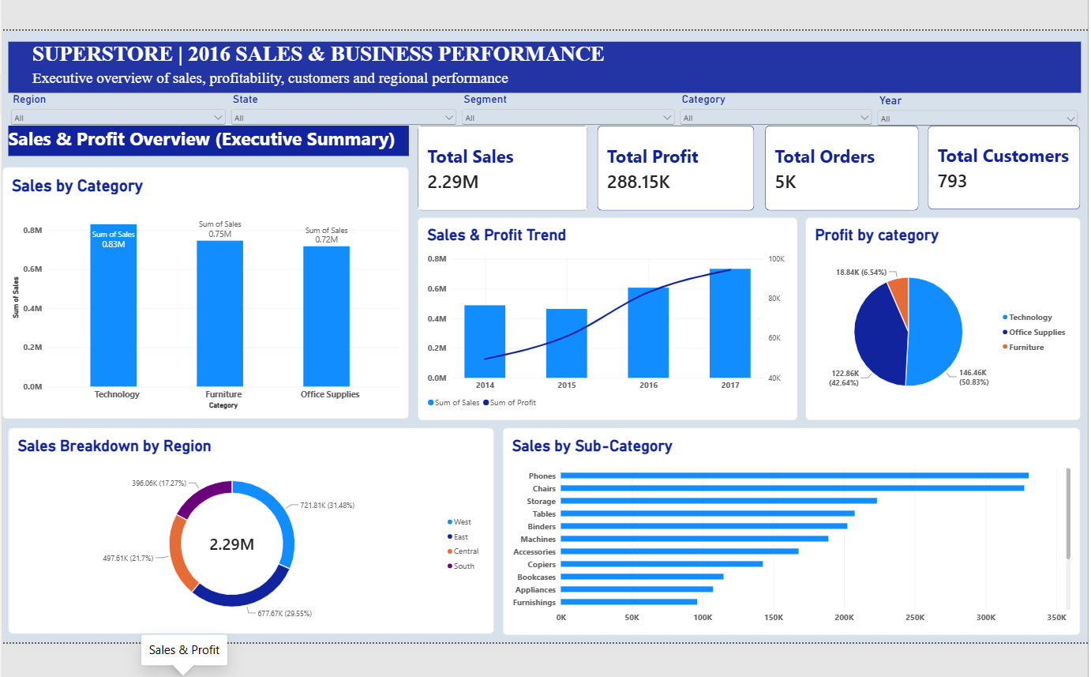

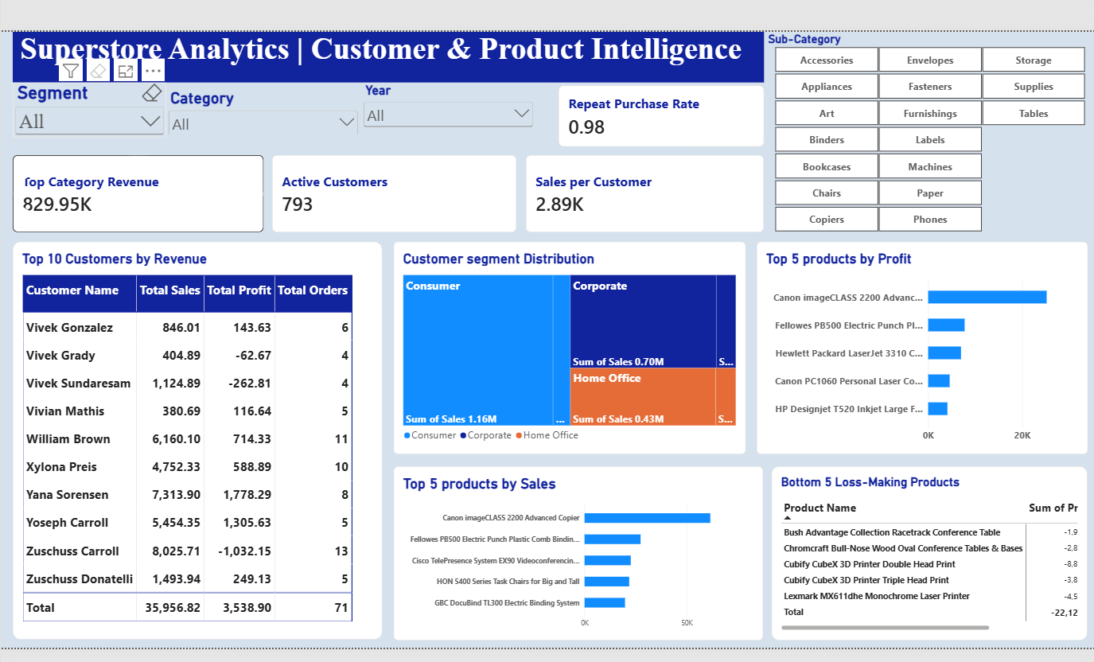

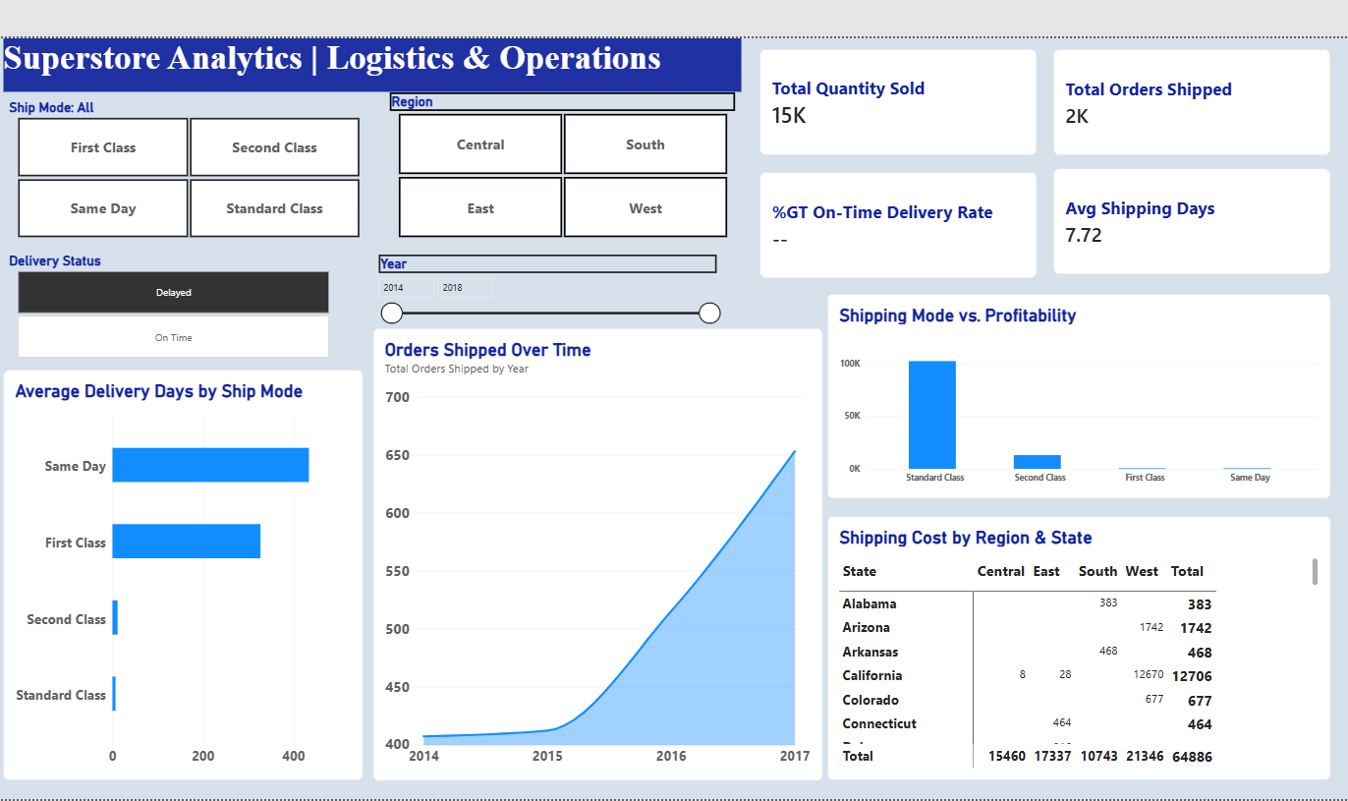
a) Purpose
The executive dashboards translate granular row transactions into an interactive reporting engine. It surfaces corporate revenue drivers, tracks multi-year margin trends, and flags regional inventory lines experiencing discount erosion.
b) Key KPIs
The master visualization layout surfaces five central operational performance matrices:
- Total Revenue: Gross cash sales valuation ($2,307,017.78).
- Net Profit: Retained performance earnings ($289,086.16).
- Profit Margin %: Comprehensive core operating efficiency percentage (12.53%).
- Units Dispatched: Aggregate metric of warehouse volume and activity (37,873 units overall).
- Invoice Count: Distinct record of customer order conversions (5,009 total orders).
c) Visualizations Used
- Dual-Axis Strategic Trends (Line/Bar combination): Compares monthly gross revenue gains alongside net margins to highlight performance variations over time.
- Categorical Performance Heat Matrix (Bar/Tree structure): Contrasts physical unit volume against gross revenue across Category and Sub-Category structures to identify low-margin segments.
- Promotional Scatter Plot Matrix: Maps applied discount rates against final profit margin results for all processed orders, revealing where heavy discounts lead to financial losses.
- Geographic Density Plot (Fill Map & Bubble): Visualizes localized market performance by plotting sales volumes and profit health across the country.
d) Slicers
- Temporal Timeline Sliders: Filters all visuals by specific Order Date boundaries to isolate fiscal years or quarters.
- Regional Grouping Elements: Sections data by operational territories (West, East, Central, South) to isolate localized structural trends.
- Market Segmentation Blocks: Filters reports by demographic profiles (Consumer, Corporate, Home Office) to track variable buying habits.

7. KEY INSIGHTS
Corporate Financial Foundation
The superstore framework maintains stable operations, generating $2,307,017.78 in total sales and capturing $289,086.16 in total profit, reflecting an overall profit margin of 12.53%.
Total Sales: $2.31M ──────────────► [ Gross Revenue Portfolio ]
Total Profit: $289K ──────────────► [ Retained Corporate Earnings ]
Overall Profit Margin: 12.53% ────► [ Consolidated Operational Efficiency ]
Strategic Product Health Inversions
A deep category analysis reveals significant profit variations across inventory lines:
[Technology] Sales: $837k │ Profit: $148k │ Margin: 17.66% (Category Anchor)
[Office Supplies] Sales: $720k │ Profit: $123k │ Margin: 17.13% (Efficiency Anchor)
[Furniture] Sales: $750k │ Profit: $18k │ Margin: 2.39% (Structural Leakage)
- Technology serves as the primary financial driver, generating $837,107.21 in sales and $147,852.87 in profit, leading all categories with a 17.66% profit margin.
- Office Supplies delivers consistent results, turning $719,764.57 in sales into $123,291.43 in net profit with a strong 17.13% margin.
- Furniture represents a major operational vulnerability; despite generating a substantial $750,146.00 in revenue, it captures just $17,941.86 in profit, resulting in a weak 2.39% profit margin due to high fulfillment costs and excessive discounting.

